Saaa travel grant slovenia 2019: call for applications
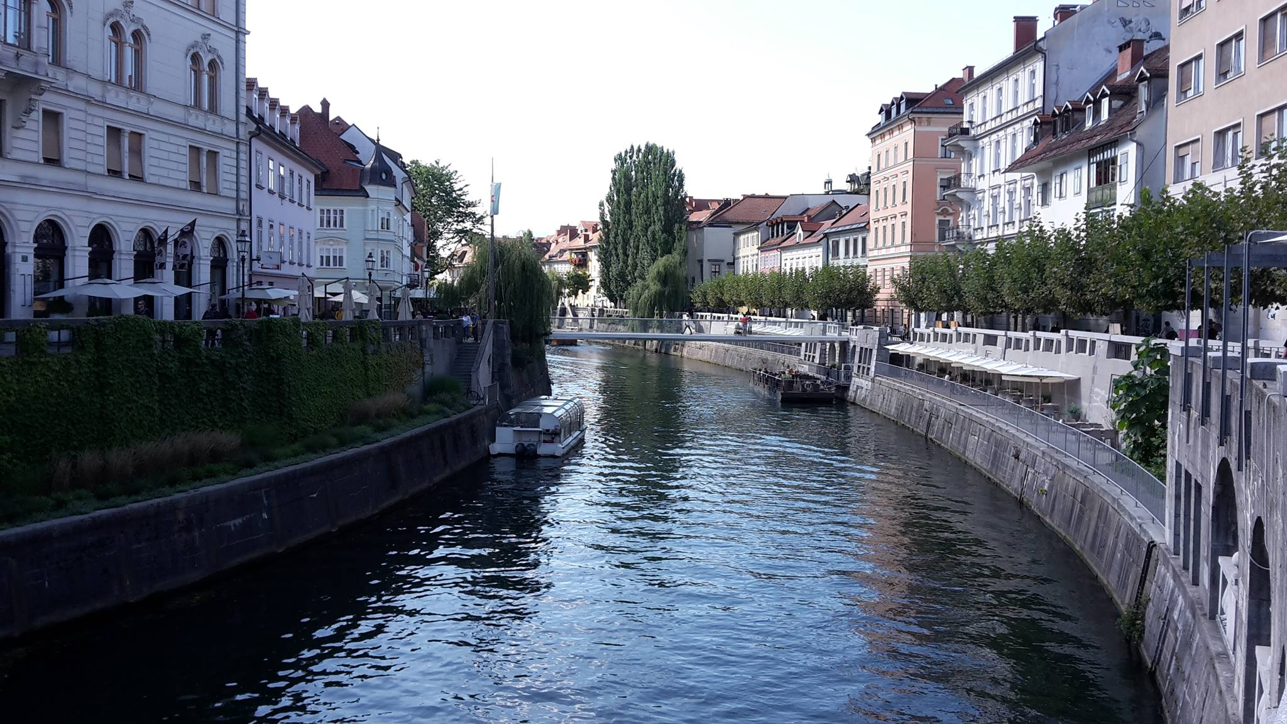
Summer in July, new friends, an amazing country and learning or improving your Slovenian language skills. Ever thought by combining all these by attending a Slovenian language summer school in Ljubljana?
Slovenian Australian Academic Association (SAAA) is offering a travel grant of 2,000 EUR to a candidate attending a 2-week course of the Slovenian language in the capital city of Slovenia, Ljubljana. The grant is supported by the Office of the Government of the Republic of Slovenia for Slovenians Abroad.
The 38th Summer School of Slovenian Language 2019 offers students a short course in Slovenian Language whilst enjoying an unforgettable summer holiday. The selected applicant will be able to choose one of the two courses offered: either between 1st – 12th July or 15th – 26th July 2019. The course will be held at the University of Ljubljana Faculty of Arts located in the very heart of Ljubljana – one of Europe’s greenest and most liveable cities. Ljubljana has a long history stretching back to the Middle Ages. The European Commission awarded Ljubljana with the coveted Green Capital of Europe title for 2016.
This 2-week course focuses on the Slovenian language, but its rich afternoon program introduces attendees of the course to a variety of concepts, including Slovenian heritage, history, traditions and culture.
Grant recipient can spend the grant money on course fee, return flights to and from Slovenia, as well as transport to and from the airports, accommodation in Ljubljana, and meals.
Upon returning from Slovenia, grant recipient will be interviewed, and will provide a short description of their experience which will be published on the website of the Slovenian Australian Academic Association in September 2019.

COURSE INFORMATION
The grant recipient will have an option to select one of the following 2 courses, both held in July:
Option 1: 1st July – 12th July 2019; or
Option 2: 15th July – 26th July 2019.
For more information on the summer school, please visit the official website of the 38th Summer School of Slovenian Language 2019.
You may want to apply for one of the scholarships provided by the summer school organisers and avoid paying the tuition fees. Applications for these scholarships are due 1st May/15th May 2019.

ELIGIBILITY
To be eligible for this grant:
- you must be 18 years or over,

- you must be a member of SAAA (If you are not a member yet, you can join by completing an online form)

Even though that applicants do not need to have Slovenian citizenship and/or be of Slovenian descent, It is desirable that applicants have some connection to Slovenia and/or Slovenian culture, through family or otherwise.

The priority will be given to younger applicants.

HOW TO APPLY:
1. Send your application via email to ziva.vuckovic.mueller@saaa.si (see instructions below).
In the email subject please write: RE: ‘SAAA Travel Grant Slovenia 2019 APPLICATION – [insert your name]’.
Your application should contain the following documents:
- Motivation letter: a short description (1000 words max.) of why you are the appropriate applicant to receive this award. Please explain why you want to learn Slovenian and how you will use the new knowledge and experiences acquired in Slovenia on your personal and professional path. Please also explain how you see your attendance in this course to contribute to the aims, vision and mission of SAAA.
- Resume including your name and surname, date and country of birth, home address, personal and educational/professional background (maximum of 2 pages)
- Other attachments proving connections and/or activities related to Slovenia (see ‘Selection process’ for more info)
2. Keep the email confirmation of your submission for your reference.

SELECTION PROCESS
Grant recipient will be selected by the 2019 SAAA Travel Grant Slovenia Committee (SAAA Board members) and announced via email and on the SAAA website. Priority will be given to candidates who have either been active in the Slovenian community in Australia or are able to promote Slovenia and Slovenian culture through other activities.

Grant recipient will be required to sign a Travel Grant Acceptance Agreement in order to receive the grant of 2000 EUR. A recipient will be required to organise their own travel, accommodation and other arrangements and will need to provide SAAA with receipts of bookings made for their travel, accommodation, course booking and any other associated arrangements with the Travel Grant award. SAAA will support the grant recipient with relevant information, but will not take any responsibility for the arrangements related to travel and stay in Slovenia. The grant recipient may want to arrange their accommodation via the Summer school official website.
Grant recipient must attend one of the offered courses, write a report about their experiences in Slovenia (2000 – 2500 words, selection of high-quality images sent as separate .jpg files: 8-10) by the due date to be published on the SAAA website and be available for a video/audio/live interview upon invitation. Please see the ‘Important dates’ section for more information about the deadlines.

IMPORTANT DATES
Applications due: 14 April 2019
Grant recipient announced via email: 29 April 2019
Travel grant acceptance contract signed by both parties: 6 May 2019
Grant recipient announced on SAAA website: 6 May 2019
Travel grant payment to the grant recipient: 10 May 2019
Scholarships by the Summer School organisers due: 1 May/15 May 2019
Language course: (Option 1) 1st July – 12th July 2019; or (Option 2) 15th July – 26th July 2019
Interview with the recipient of the grant : By the end of August 2019 (TBA)
Grant recipient’s report submitted to SAAA due: End of August 2019
CONTACTS
SAAA Travel Grant Manager
Ziva Vuckovic Mueller
ziva.vuckovic.mueller@saaa.si
Wishing you the best of luck with your application!

